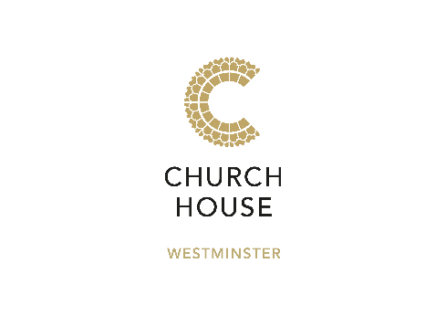

Sandwich Lunches
Our lunch bags are pre-packed and can be easily collected from a designated area to be enjoyed in your meeting room or a designated catering space.
Appropriate cutlery and napkins will be provided along with clear physical distance signage and hand sanitiser will be available in all rooms.

Classic Sandwich Bag £14.75 per person
Sandwich selection
Whole seasonal fruit
Corkers crisps
Cloudy lemonade can

Executive Sandwich Bag £16.75 per person
Artisan sandwich or baguette
Fruit salad
Chewy chocolate brownie
Corkers crisps
Cloudy lemonade can

Additional options on page 2

Boxed Salad Bag £17.75 per person
Please choose one boxed salad for the group plus a vegetarian / plant-based option
- Roast chicken, lentils, fresh herbs, baby leaves
- Chicken Caesar, penne pasta, mixed leaves, parmesan
- Asian soy, chilli, spring onion & quinoa salad (Plant based)
- Plant based Mezze, mixed leaves
- Pole caught tuna, penne pasta, baby leaves
Mini baguette and butter
Seasonal fruit salad
Cherry Bakewell tart
Cloudy lemonade can

Enhance your lunch with a selection of these items:
All items are pre-packaged and will be served fully covered or with appropriate lids

Carrot and humus pots £3.50 per person
Falafel and tzatziki pot £3.50 per person
Borders biscuits £1.00 per person
Plant based brownie £2.00 per person
Summer berry flapjack £2.75 per person

